The Flags That Flew Over Castle Pinckney:
Research, Analysis, Findings, and Recommendations

Submitted by Tom Elmore
April 2013

Overview and Purpose:

I was contacted via e-mail by Rick Dorrance, Executive Director, Castle Pinckney Historical Preservation Society on April 6, 2013 about researching which flags flew over the fort in Charleston, S.C. harbor from 1818-1878. Having a personal interest in vexillology(the study of flags) I jumped at this opportunity.

However, this project provided some challenges as written, photographic or illustrated records are often hard to find and very often vague. Consequently I have found myself acting like one of the team members of the popular television show Mythbusters as I have had to judge the usage of flags over the fort as confirmed, plausible or “busted.” Adding to the pressure of this is that South Carolina is at the epicenter of an ongoing debate over the meaning and usage of flags used by the Confederate States of America from 1861 to 1865, during which time the fort was a Confederate military installation.

Unless there is definite proof or enough circumstantial and/or anecdotal evidence to conclude that a flag flew or probably flew it was not included. In the course of this investigation I have found that that over two dozen flags flew over the castle during those sixty years. That number, however, may be low as there may be other banners that have flown over the fort that are either lost to history or whose usage cannot be sufficiently verified.

I have grouped the flags into three categories, United States Flags, Confederate Flags and Palmetto/Secession Flags. In each category I have included my thoughts on the various banners as to why I think they flew over the fort.

I am indebted to the Castle Pinckney Historical Preservation Society for having this fascinating opportunity, and hope that they will find my research both useful and interesting. I am looking forward to the day when these banners will fly over a restored Castle Pinckney.

United States Flags

Pre-Civil War

Though many view Castle Pinckney as a Confederate fort, for most of its history it has flown the flag of the United States of America.

Prior to the Civil War the fort was fully garrisoned only twice, during the years 1818-1819 after the War of 1812 and from 1832-1835 during the “Nullification Crisis.” In 1835, the garrison was removed to Florida to fight in the Seminole Indian War. The rest of the time the fort was manned by a caretaker and/or a skeleton crew, though the structure was always maintained. Thus, Castle Pinckney would have flown the regulation U.S. flag until the fort was seized by the state of South Carolina on December 27, 1860.

Illustrations US1 (United States) to US14 show the fourteen official United States flags from 1818 to1861. For the reasons stated above, it is my personal belief that most, if not all, of the flags illustrated flew over the fort. With one exception I did not include variations that put the stars in a pattern (such as a star or a circle made of stars) because it cannot be authenticated that such a flag flew over the castle. However, since we know that one such pattern was used at Fort Sumter (US14a) it is possible that this and other such designs may have flown over Castle Pinckney.

U.S. Flags Flown at Castle Pinckney

Pre-Civil War (15)

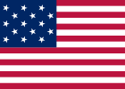
US1
15 Stars and Stripes
(The Star Spangled Banner)
1795-1818

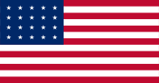
US2
20 Star Flag
1818-1819

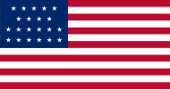
US3
21 Star Flag
1819-1820

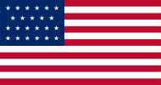
US4
23 Star Flag
1820-1822

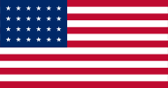
US5
24 Star Flag
1822-1836

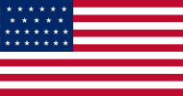
US6
25 Star Flag
1836-1837

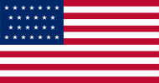
US7
26 Star Flag
1837-1845

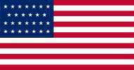
US8
27 Star Flag
1845-1846

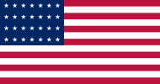
US9
28 Star Flag
1846-1847

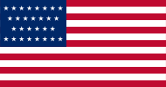
US10
29 Star Flag
1847-1848

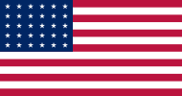
US11
30 Star Flag
1848-1851

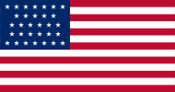
US12
31 Star Flag
1851-1858

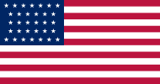
US13
32 Star Flag
1858-1859

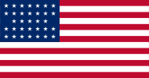
US14
33 Star Flag
1859-1861

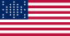
US14a
Fort Sumter Garrison Flag
1861

Post-Civil War

The fort was reclaimed by the U.S. Army on February 18, 1865 after the Confederate evacuation of Charleston the day before. Lt. Col. A.G. Bennett, commander of the 21st U.S. Colored Infantry placed United States flags at Castle Pinckney sometime between 9 and 10 a.m. that day.

Soon after the fall of Charleston to Union forces on February 18, 1865 until 1868 the fort was used as a prison. Afterwards, Castle Pinckney was used only as a light station and supply depot by The Wart Department, who had little use for it. In 1878 it was transferred to the U.S. Treasury Department.

Illustrations US15 to US18 show the official United States flags of 1865-1878. I included an image of the flag design of the U.S. flag raised over Fort Sumter in 1865. (US15a) Again, while we cannot say with any certainty that this flag flew over Castle Pinckney, we cannot rule it out, or the possibility of other variations in star patterns. Given that the fort was constantly in use, even if just sparingly, by the War Department, I feel it is safe to assume that all standard U.S. flags designs shown were used at Castle Pinckney.

Post-Civil War (5)

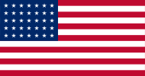
US15
35 Star Flag
1863-1865

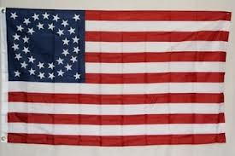
US15a
Fort Sumter Flag
1865

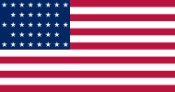
US16
36 Star Flag
1865-1867

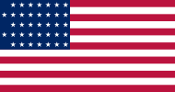
US17
37 Star Flag
1867-1877

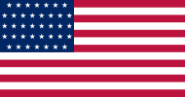
US18
38 Star Flag
1877 – 1890

Confederate Flags

By the time the Confederate States of America was formed on February 4, 1861, Castle Pinckney had already been occupied for over a month. One month later the Confederate States adopted its first national flag, often referred to as the “Stars and Bars.” The design of the flag is often attributed to Nicola Marschall of Alabama who based it on the Austrian flag.

Illustrations CS1 toCS4 (Confederate States) show the four official variations of the Stars and Bars, each featuring a different number of stars. The first one (CS1) with seven stars can be authenticated as having flown in Charleston based on contemporary illustrations and a photo of the interior of Fort Sumter taken shortly after the Union evacuation of the fort.Therefore it goes to reason that it was used at Castle Pinckney.

CS1
7 Stars First National
“Stars and Bars”
March 4, 1861 – May 21, 1861

CS2
9 Stars First National
May 21, 1861 – July 2, 1861

CS3
11 Stars First National
July 2, 1861 – November 28, 1861

CS4
13 Stars First National
November 28, 1861 – May 1, 1863

As for the other three, I consider it probable that they were used since the Charleston firm of Hayden & Whilden was making First Nationals until February 1863.

The second Confederate national flag or the “Stainless Banner” was adopted May 26, 1863 and was still in use at the time the Confederates left Charleston. The change was made because many felt that the Stars and Bars resembled the Stars and Stripes too closely, especially on the battlefield.

One of the only two known flags to fly over Castle Pinckney that still survives is a Second National. (CS6 and CS7) It was captured by Lt. Col. Bennett on February 18, 1865. When he and his men occupied Castle Pinckney “the rebel flags were hauled down and the American flag substituted.” It was returned to South Carolina in 1905 by the U.S. War Department. It is now in the possession of the South Carolina Confederate Relic Room and Military Museum. It measures 9 feet x 14 feet and is in very bad condition

CS5
Second National Flag
“The Stainless Banner”
May 26, 1863 – March 4, 1865

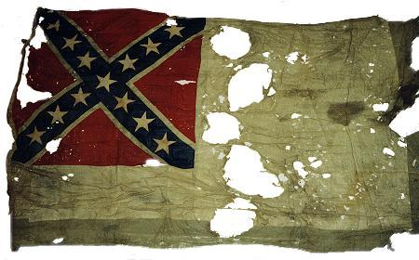
CS6
Castle Pinckney Flag (Front)
Image Copyrighted by Dennis Todd, used by permission for non-commercial purposes.

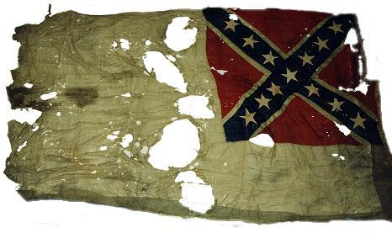
CS7
Castle Pinckney Flag (Back)
Image Copyrighted by Dennis Todd, used by permission for non-commercial purposes.

The Confederate Battle Flag or “Southern Cross” (CS8) is easily the most recognizable and controversial symbol of the Confederacy today. Its design is credited to South Carolinian William Porcher Miles, though Confederate General Joseph Johnston modified it from a rectangle to a square. It would become known as the Battle Flag of the Army of Northern Virginia (ANV) though it was used throughout the south. Later in 1864, a rectangular version was approved for use by Confederate troops in the western theatre of the war.

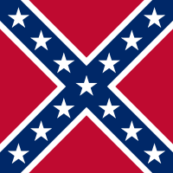
CS8
Battle Flag of the Confederate Military
Department of South Carolina, Georgia and Florida
“The Southern Cross”
1863-1865

When Gen. P.G.T. Beauregard assumed command of the Confederate Military Department of South Carolina and Georgia (and later Florida) in September 1862, he decided to standardize the flags of his command. He replaced the variations of first nationals, South Carolina state flags and other regimental flags with a version of the ANV flag.
Beauregard’s flags were distributed by the Charleston Depot, who contracted out their manufacturing. They were first distributed in Spring 1863 with elaborate ceremonies in the Charleston area. On April 20, 1863 Beauregard presented flags from the Charleston Depot to the brigades of Generals States Rights Gist and T.L. Clingman. The troops cheered their new flags and vowed to defend them.

According to the Museum of the Confederacy in Richmond, Va.:
The Charleston Depot flags came in three overall sizes; 48 inches square for infantry and coastal artillery and 36 inches square for cavalry and field artillery, as well as some 30 inch square flags also for artillery units. Instead of having eyelets for attachment to flagpoles, these flags used colored sleeves; blue for the former flags and red for the latter. The crosses were 8 inches wide on infantry models and the stars were 4 1/2 inches across and spaced every 8 inches. Unlike the ANV flags, the white bunting borders were sewn to all four sides (ANV flags had the borders on 3 sides, and then the canvas hoist border).

Unlike the ANV flags which were made with the field being constructed first, the Charleston Depot flags were made with the cross as the basis for construction. Three pieces were sewn together in an overlap fashion. From there the white edging along the cross was sewn to the edges. This edging was wider on these flags than on ANV flags. Next, the red fields, cut in quadrants, was sewn to the edges of the white edging. This, therefore, required cutting the cloth to the right size before sewing to the flag.
Afterwards the exterior borders were sewn to the edges, but not in the overlap fashion of the ANV flags. Instead, these borders were extensions of the fields, and while decorative, did not reinforce the exterior edges of the flags like the borders of the ANV flags did. This would surely result in the edges wearing out sooner than the edges of ANV flags. Overall, these flags were made using quilting techniques of the day, which fit well with the sewing styles of the ladies contracted to make them. But it was a longer process to sew them and as such, they could not have been produced as rapidly as the ANV flags could.
Based on Beauregard’s orders, the previously noted comments of Lt. Col. Bennett, and other antidotal evidence, I feel confident that the square battle flag of the Confederate Military Department of South Carolina, Georgia and Florida flew over Castle Pinckney. I also feel that given the available information, it is probable that the Confederate regiments that occupied the fortress used variants of this flag.
Only two Confederate military regiments are known to have been stationed at Castle Pinckney. The first was the Charleston Zouave Cadets, which later became a part of the 1st Regiment Rifle, S.C. Militia. The Zouaves were assigned to the fort in September 1861 until March 1862 to guard prisoners.

Though the cadet’s flag no longer exists, we have an excellent description of it: “A Palmetto tree, with a crouching Tiger - the motto of the company Droit et Avant (Right and to the Front) at the base… this flag was further described as being ‘Red with a Palmetto tree in the center, and around the tree a rattlesnake, and near it a crouched tiger. A single star completes the symbolism.’” Unfortunately, I have been unable to locate an image of this banner

The cadets were replaced by the First South Carolina Regiment of Artillery which was stationed there until the fort was evacuated. A blue, white and gold war time silk flag of the unit survives and is owned by the Charleston Museum. But it appears to be a presentation flag that was probably never used in battle.

Palmetto Flags/Secession Banners

These are the flags that flew over Castle Pinckney from December 27, 1860 to the adoption of the flag of the Republic of South Carolina on January 26, 1861. This has been by far the hardest group to examine.

Though the design of the familiar indigo blue flag with a white palmetto and a gorget, or crescent moon, dates back to the American Revolution and was carried by the Palmetto Regiment in the Mexican-American War, it was not until January 1861, that it became the official flag of South Carolina.

On January 26, 1861, the legislature approved the design of the Flag of the Republic of South Carolina. (PS1-Palmetto/Secession) This flag was similar to the current state flag except that the palmetto tree was gold in a white oval. An example of one is currently on display at the South Carolina Confederate Relic Room and Military Museum in Columbia, S.C.

This flag lasted for only two days as concerns about how difficult it would be to manufacture led to the legislature removing the oval and making the palmetto tree white on January 28, 1861. (PS2) This flag would have replaced any previous flag flying at Castle Pinckney, until it was replaced by the first Confederate national. It is important to note that this flag has the gorget, or crescent moon lying on its back and not at the angle AS on the modern flag.

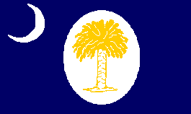
PS1
First Republic of South Carolina Flag
“The Two Day Flag”
Adopted January 25, 1861

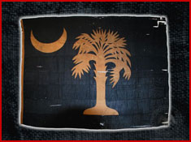
PS2
Second Republic of South Carolina Flag
Adopted January 28, 1861
(Photo from the Iowa Historical Society website)

A flag that has been authenticated as flying over the fort on February 1, 1860 is a secession flag now in the possession of the South Carolina Historical Society. (PS3) It was carried to Fort Walker on Hilton Head Island, S.C. by Major J.A. Wagner. The then 10' x 20’ flag features two Palmetto Trees, fifteen stars in red field, and fifteen blue & white stripes which stood for the fifteen slave states. It was taken from Fort Walker by Union forces under the command of Rear Admiral Samuel FrancisDu Pont on November 7, 1861. Because of where it was captured it is often referred to as the “Fort Walker Flag.”

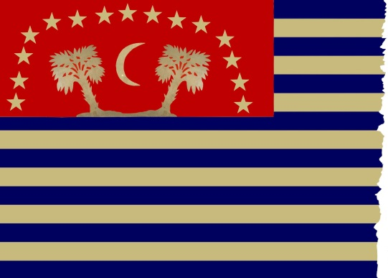
PS3
Secession Flag
“Fort Walker Flag”
Image Copyrighted by Dennis Todd, used by permission for non-commercial purposes.

The image below from the March 8, 1862 issue of Harpers Weekly shows the flag on display inside the U.S. Capital building during war almost in the center between the third and fourth columns.

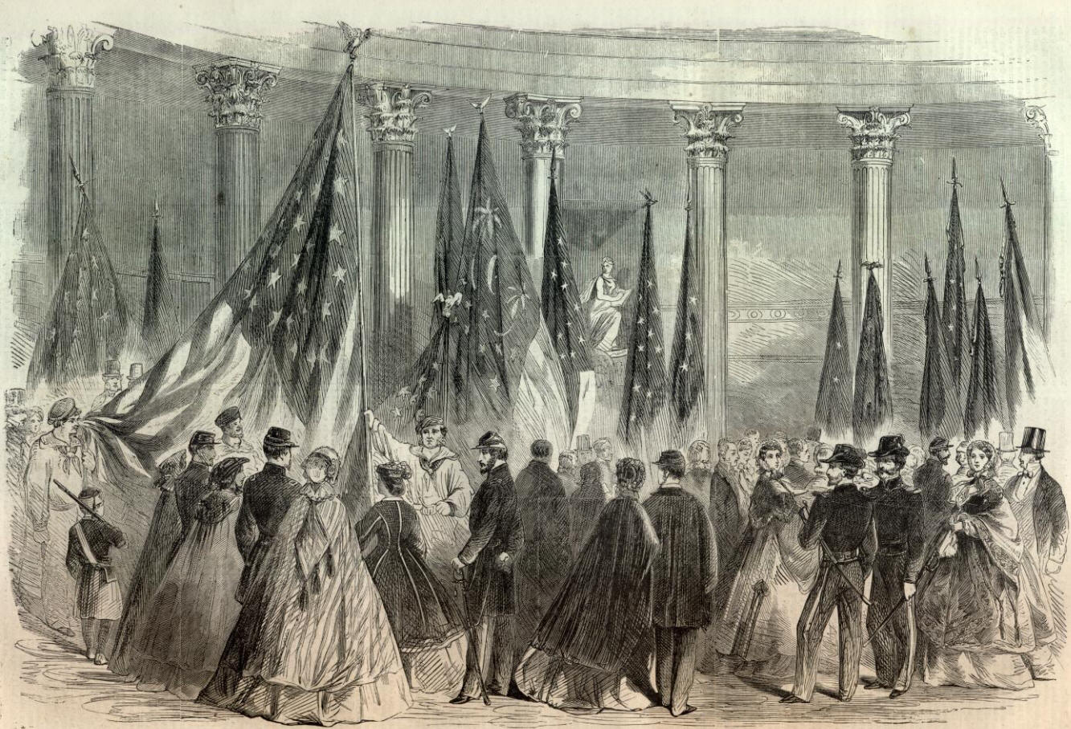

From here trying to determine which state and/or secession flags flew over castle Pinckney becomes tougher as all we have to go on is a black and white illustration and vague written descriptions. Case in point: President James Buchannan received a report that on December 28, 1860 the "palmetto flag floated out to the breeze at Castle Pinckney.” Furthermore a Union officer at Fort Sumter noted in January 1861that the flags at Castle Pinckney and at Ft. Johnson were “similar” to the one flying over the Star of the West battery which was similar to the current South Carolina state flag except that it was red instead of blue. This begs the question if the flag was similar to the current South Carolina state flag or a variation?

The image below from Frank Leslie’s Illustrated Newspaper January 26, 1861 clearly shows a palmetto flag flying over the fort, but there is no mention as to what the color of the flag is. Also there is no gorget on the flag in the image either. Though it was published two days before South Carolina adopted its indigo state flag, the artist probably made the drawing weeks in advance.

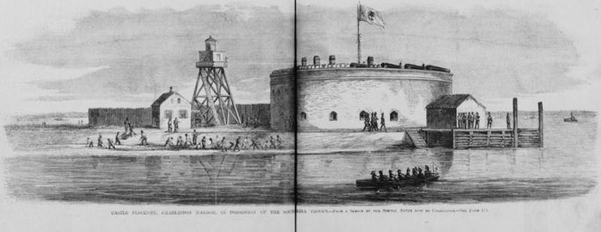

The reason why color is in question is because many of the numerous secession flags that flew around Charleston and Charleston Harbor in late 1860-early 1861 were either white or red, and many of them featured the palmetto tree. Thus we cannot say for certain based on President Buchanan’s comments and the illustration what color this flag was.

Compounding this confusion is that there are two conflicting accounts of what flag was raised over Castle Pinckney the night it was taken by the South Carolina Militia. While both accounts agree that the militiamen had no flag with them and had to take one from a boat, what they took is a source of debate.

One account says that they procured a flag from the boat Nina and that flag was a star on a red field (PS4) which sounds like a variation on the more popular and famous Bonnie Blue Flag. (PS5). However the only reference I can find to a flag similar to this places it in Texas in 1842, though one Texas county used it as their secession flag. Therefore the validity of this tale is questionable, leading me to accept the other accounts that say a palmetto flag was flown.

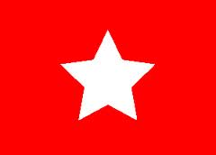
PS4
“The Nina Flag”
(Conceptual Image.)

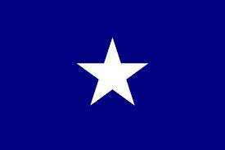
PS5
Traditional Bonnie Blue Flag

We also have an eye witness account from Union Capt. J.O. Foster who wrote on January 21, 1861 that the flag on Morris Island had “a red field with white palmetto tree upon it. The flag on Fort Johnson is similar, as is also the one on Castle Pinckney. That on Fort Moultrie is a white field with a green palmetto tree and a red star in the corner.”

Foster’s comment that the Moultrie flag is white suggests that none of the other flags were. So were they red or blue or what?

In 2009 the Citadel Historical Council made a study of a flags flown in Charleston during this period in order to authenticate a red South Carolina state flag then in the possession of the Iowa Historical Society. Affectionately known as “Big Red,” (PS6) this flag was used by the Citadel Cadets when they fired on the Star of the West on January 9, 1861. Though the report focused primarily on “Big Red” it does provide valuable information that is useful in determining what did or did not fly over Castle Pinckney.

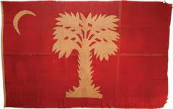
PS6
The Citadel’s “Big Red”
(Photo from the Iowa Historical Society website)

Among their findings is that Hugh Vincent was commissioned to make flags for the Republic of South Carolina, and written accounts suggests that they were red and that red secession flags were not uncommon during this period. However they felt that the term “similar” did not mean that the flags flying around the various batteries in Charleston harbor were identical.

The Fort Walker flag has two palmetto trees on it. But they are not prominent, so it seems unlikely that this was the flag that Foster was referring to.

Consequently, based on all the available data, and assuming the flag in the illustration of Castle Pinckney is accurate, admittedly a big “if,” I theorize that a flag identical to The Citadel’s “Big Red,” minus the gorget, or the gorget replaced by a star, may have flown over the fortress in late 1860-early 1861. I also feel that the previously mentioned flag of Charleston Zouave Cadets also probably flew over the fort. While both certainly meet the descriptions of a “palmetto flag,” this is at best an educated guess, and unless we discover some long lost picture, description or a banner itself, we can never be sure.

Recommendations

As tempting as it is to display every flag that has flown over Castle Pinckney, the economic realities may make this idea cost prohibitive as good quality flags are not inexpensive. Plus given the winds and the other climate variables in Charleston Harbor, it is quite probable that any flag that flies over the castle will have a relatively short life span.

As such I recommend to the Castle Pinckney Historical Preservation Society that the following twelve flags be flown over the fort:

- US1-The Star Spangled Banner was the first U.S. Flag to fly over the fort and is one of the most recognizable U.S. flags in history.
- US5-This 24 star flag flew longer over the fort than any other flag during the pre-Civil War era. It also flew during a period when the fort was fully garrisoned.
- US9-Flag used during the Mexican-American war.
- US14-The last U.S. flag to fly over the fort before being seized by the State of South Carolina. One may also want to consider US14a as well.
- US15-The First U.S. flag flown over the fort after the war. Likewise you may want to consider US15a.
- US18-the last flag flown while Castle Pinckney belonged to the U.S. War Department.
- CS1-First Confederate flag flown over the fort. It also serves as a reminder that South Carolina was the first state to leave the Union and was one of the original seven Confederate States.
- CS5-Last Confederate national flag to fly over the fort. I would recommend, if possible, using one that matches the dimensions of the one in the Relic Room.
- CS8-I know that displaying the “Southern Cross” any place, anywhere and at any time will create controversy, but as long as it is the square version made to the specifications of the Charleston depot issue, and it is explained as such, it would pass the test of historic accuracy and lessen any potential problems.
- PS2- We know that from December 1860-February 1861 “palmetto flags” flew over the fort and this is one of only two we can be 100% certain of. If possible, fly one with the gorget lying on its back as it would be more historically appropriate than the current South Carolina state flag.
- PS3-This is one of only two known surviving flags to have flown over Castle Pinckney. The drawbacks are that it would have to be custom made and you may have to get permission from the South Carolina Historical Society. If it can be done, I say do it as beside its historical significance, it is a very unique South Carolina flag.
- Since there is apparently no readily available illustration of it, I would recommend that, assuming funds are available, an artist be commissioned to recreate the design of the flag of the Charleston Zouave Cadets, and if possible that the next step be taken and a recreation of it be flown over Castle Pinckney.
References

The Carolina Rifles, Company F, 17th SCV, Carolina Rifles Military Reenactors Association,
http://trampsbrigade.freeforums.org/castl-pickney-photos-t318.html.rolina Rifles, ompany F, 17th SCV
Cannon, Devereaux D. Jr. The Flags of the Union, An Illustrated History. Pelican Publishing. 1994.

Cannon, Devereaux D. Jr. The Flags of the Confederacy, An Illustrated History. Pelican Publishing. 1994.

Citadel Historical Council, Big Red Report: Research, Analysis, Findings, and Recommendations.http://www.citadelalumni.org/Broadcast/bigredreport.pdf.2009.

Confederate Battle Flags' History.http://crwflags.com/fotw/flags/us-csah2.html#part2. 2010

Crute, Joseph H. Jr., Emblems of Southern Valor-The Battle Flags of the Confederacy. Olde Soldier Books, Inc. 1990.

Dedmondt, Glenn, The Flags of Civil War South Carolina. Pelican Publishing Company.2000.

The Iowa Historical Society. http://www.iowahistory.org/museum/battleflags/gallery/confederate.htm.

Katcher, Phillip, Flags of the Civil War. Osprey Publishing. 2000

Lewis, Kenneth E. and William T. Langhorne Jr., Castle Pinckney: An Archeological Assessment with Recommendations 1978. http://scholarcommons.sc.edu/cgi/viewcontent.cgi?article=1144&context=archanth_books

Quaife, Milo M., et al. The History of the United States Flag. Harper Row, Publishers. 1961

Rollins, Richard, The Returned Battle Flags. Rank and File Publications. 1995.

Rosen, Robert N., and Richard W. Hatcher III, Images of America-The First Shot. Arcadia Publishing. 2011

Various, The Civil War At Charleston. The [Charleston, S.C.] News and Courier and The [Charleston, S.C.] Evening Post. 1966

War of the Rebellion- A Compilation of the Official Records of the Union and Confederate Armies. Washington, D.C. Government Printing Office, 1880-1901

Weirick, David, Castle Pinckney: Past, Present, Future-A Thesis Presented to the Graduate Schools ofClemson University and the College of Charleston.http://etd.lib.clemson.edu/documents/1340723074/Weirick_clemson_0050M_11712.pdf. 2012

Williams, Earl P. What You Should Know About The American Flag. Maryland Historical Press. 1987.

Williams, Earl P. What You Should Know About The Flags of the Confederacy. Thomas Publications, Gettysburg, PA. 1993.

Additional information provided by
Dennis Todd, Historian, South Carolina Division, Sons of Confederate Veterans.

Period illustrations are from the Library of Congress.

Endnotes

Lewis, Kenneth E. and William T. Langhorne Jr., Castle Pinckney: An Archeological Assessment with Recommendations 1978. http://scholarcommons.sc.edu/cgi/viewcontent.cgi?article=1144&context=archanth_books, Pgs.17, 20-21
Information on U.S. flags designs and dates come from www.Wikipedia.com. It was not until the adoption of the 48th star flag in 1912 that star patterns were set by law. Patterns shown are called the usual pattern as used by the U.S. Navy. Only the U.S. Army allowed variations in star patterns prior to 1912.
War of the Rebellion- A Compilation of the Official Records of the Union and Confederate Armies. Washington, D.C. Government Printing Office, 1880-1901. (Henceforth referred to as O.R.) Vol.47/1 Pgs. 1018-1019 Based on Bennett’s account, I feel it safe to say that no U.S. Army regimental flags flew over the fort at this time.
Lewis and Langhorne Pg. 29. Black U.S. troops were referred to as “Colored” during the Civil War.
Crute, Joseph H. Jr., Emblems of Southern Valor-The Battle Flags of the Confederacy.1990. Olde Soldier Books, Inc., Gaithersburg, MD. Pgs. 12-13Confederate military uniforms were based on the uniforms of the Austrian army. Some give credit to the flag design to Orren R. Smith of North Carolina, but Marschall’s claim is considered the strongest.
Rosen, Robert N., and Richard W. Hatcher III, Images of America-The First Shot. 2011. Arcadia Publishing, Charleston, S.C., Pgs. 89, 110. Data on Confederate National Flag designs and dates comes from www.wikipedia.com.
Various, The Civil War At Charleston .1966. The [Charleston, S.C.] News and Courier and The [Charleston, S.C.] Evening Post, Charleston, S.C., Pgs.4, 22, 38, Confederate Battle Flags' History, 2010. http://crwflags.com/fotw/flags/us-csah2.html#part2. This informationwas written for an exhibit at the Museum of the Confederacy in Richmond, Virginia
OR/Vol. 47/1 pgs. 1018-1019
, Rollins, Richard, The Returned Battle Flags. 1995. Rank and File Publications Redondo Beach, Ca. (no page number). Additional information provided by Dennis Todd, Historian, South Carolina Division, Sons of Confederate Veterans.
Crute, Pg. 29, Katcher, Phillip, Flags of the Civil War, 2000 Osprey Publishing , Oxford, England, Pg.39
Katcher, Pgs. 39 -.41
http://www.crwflags.com/fotw/flags/us-csah2.html#part2
Ibid
Weirick, David, Castle Pinckney: Past, Present, Future-A Thesis Presented to the Graduate Schools of Clemson University and the College of Charleston. 2012. http://etd.lib.clemson.edu/documents/1340723074/Weirick_clemson_0050M_11712.pdf Pg. 51, 53, 54
http://trampsbrigade.freeforums.org/castl-pickney-photos-t318.html. See also Dedmondt, Glenn, The Flags of Civil War South Carolina.2000. Pelican Publishing Company. Gretna, La. Pg. 63 for an illustration of a flag of the South Carolina Zouaves Volunteers which was said to be based on the Charleston Zouave Cadets flag.
Werrick, Pg. 54, Dedmondt, Pg. 127
Some sources say that the palmetto tree was to be green and brown, but there are no known surviving examples.
Image of the red and blue South Carolina flags taken from the Iowa Historical Society website http://www.iowahistory.org/museum/battleflags/gallery/confederate.htm. The angle of the gorget was changed around 1911.
Illustration and information provided by Dennis Todd. According to Todd, the flag today is 10x12 feet. It is probable that pieces of the flag were given away as souvenirs over the years.
Image from the Library of Congress and is in the public domain.
O.R. 1/118
Citadel Historical Council, Big Red Report: Research, Analysis, Findings, and Recommendations. 2009. http://www.citadelalumni.org/Broadcast/bigredreport.pdf , Pg.6
Image from the Library of Congress and is in the public domain.
Dedmondt, Pgs. 13-19
Big Red Pg.10, http://www.crwflags.com/fotw/flags/us-txhs.html
O.R. 1/147
Big Red, Pg. 6

